

Brenchley & Matfield Booking form 2024/2025

From Term 5, 2025 once OFSTED approved

FULL NAME OF CHILD 1___________________________________________Year________________

FULL NAME OF CHILD 2___________________________________________Year________________

CHILD 1 DATE OF BIRTH _____/_____/________ CHILD 2 DATE OF BIRTH _____/_____/________

HOME ADDRESS _____________________________________________________________________

________________________________________________________POSTCODE__________________ PARENT/CARER name ________________________________________________________________

Home Tel. no: ___________________________Work Tel. no: _______________________________

Mobile Tel. no: __________________________Email:______________________________________

|  |  |  |  |  |  |
| --- | --- | --- | --- | --- | --- |
| **START DATE**  **/ /** | **Please tick the days you require: EVERY (TERM TIME ONLY)** | | | | |
| **MONDAY** | **TUESDAY** | **WEDNESDAY** | **THURSDAY** | **FRIDAY** |
| **EARLY SESSION**  **3.30 PM–4.30 PM**  **(Limited Spaces)** |  |  |  |  |  |
| **LATE SESSION**  **4.30 PM–6 PM** |  |  |  |  |  |
| **FULL SESSION**  **3.15 PM–6 PM** |  |  |  |  |  |
| **EXCEPT**  List any specific dates you do not require |  |  |  |  |  |

**We do not charge for non-attendance on INSET days and will credit you for these days if they are not known at the time of invoicing.**

**PLEASE NOTE: ALL PLACES BOOKED WILL BE CHARGED FOR WHETHER YOUR CHILD ATTENDS OR NOT unless you give us 10 days’ notice of non-attendance. I agree to the payment & booking terms.**

Signed:________________________________________________ Dated:______________________

Please email your completed form to: newtonlangcc@gmail.com

Newton Lang Childcare – B&M Booking Form – 2024/2025



[**https://www.bishopchavasseschool.org.uk/term-dates/**](https://www.bishopchavasseschool.org.uk/term-dates/)

**Terms:** Fees are payable monthly in advance. We will not charge you for an Inset day. If an Inset day is not known at the time of invoicing, we will credit you for the day. **We require 10 days’ notice for a change or cancellation of a day booked above without which you will be charged.** We will adjust and send you an amended invoice for any changes but this will usually only happen once a month or on request. Please notify us of changes in writing, by text message or email. Non receipt of invoice is no excuse for non-payment of fees. **Late payment of fees will incur an administration fee of £5.00 per week until payment is received** and we reserve the right not to admit your child/children until all fees and surcharges have been received in full. A late collection fee of £5.00 per 15 minutes or part thereof is payable after 6.30pm. We accept payment by childcare vouchers or direct bank transfer. Payments by cheque and cash deposits incur additional banking charges. Please discuss with us if you have any questions.

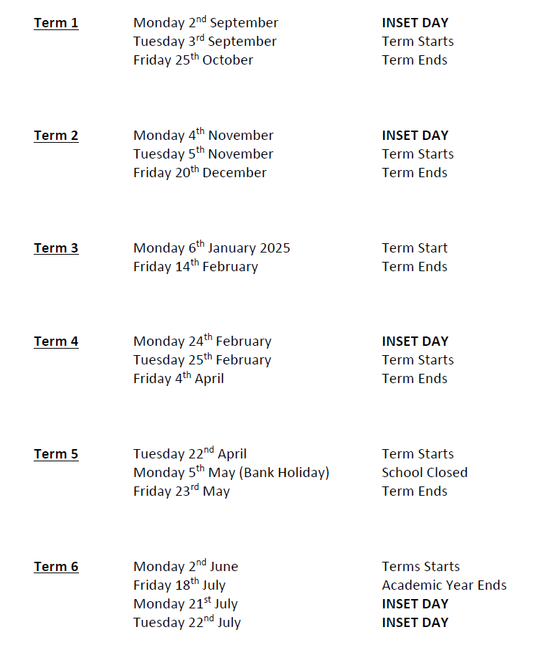

Newton Lang Childcare – B&M Booking Form – 2024/2025