Newton Lang Childcare
Booking form 2020/2021

FULL NAME OF CHILD 1_______________________________________________________________
FULL NAME OF CHILD 2_______________________________________________________________
SCHOOL ___________________________________________________________________________
COLLECTION FROM SCHOOL REQUIRED? Yes / No (non Fermor additional fee per child is payable)
CHILD 1 DATE OF BIRTH _____/_____/________ CHILD 2 DATE OF BIRTH _____/_____/________
HOME ADDRESS
___________________________________________________________________________________
________________________________________________________POSTCODE__________________ PARENT/CARER name ________________________________________________________________
Home Tel. no: ___________________________Work Tel. no: _______________________________
Mobile Tel. no: __________________________Email:______________________________________
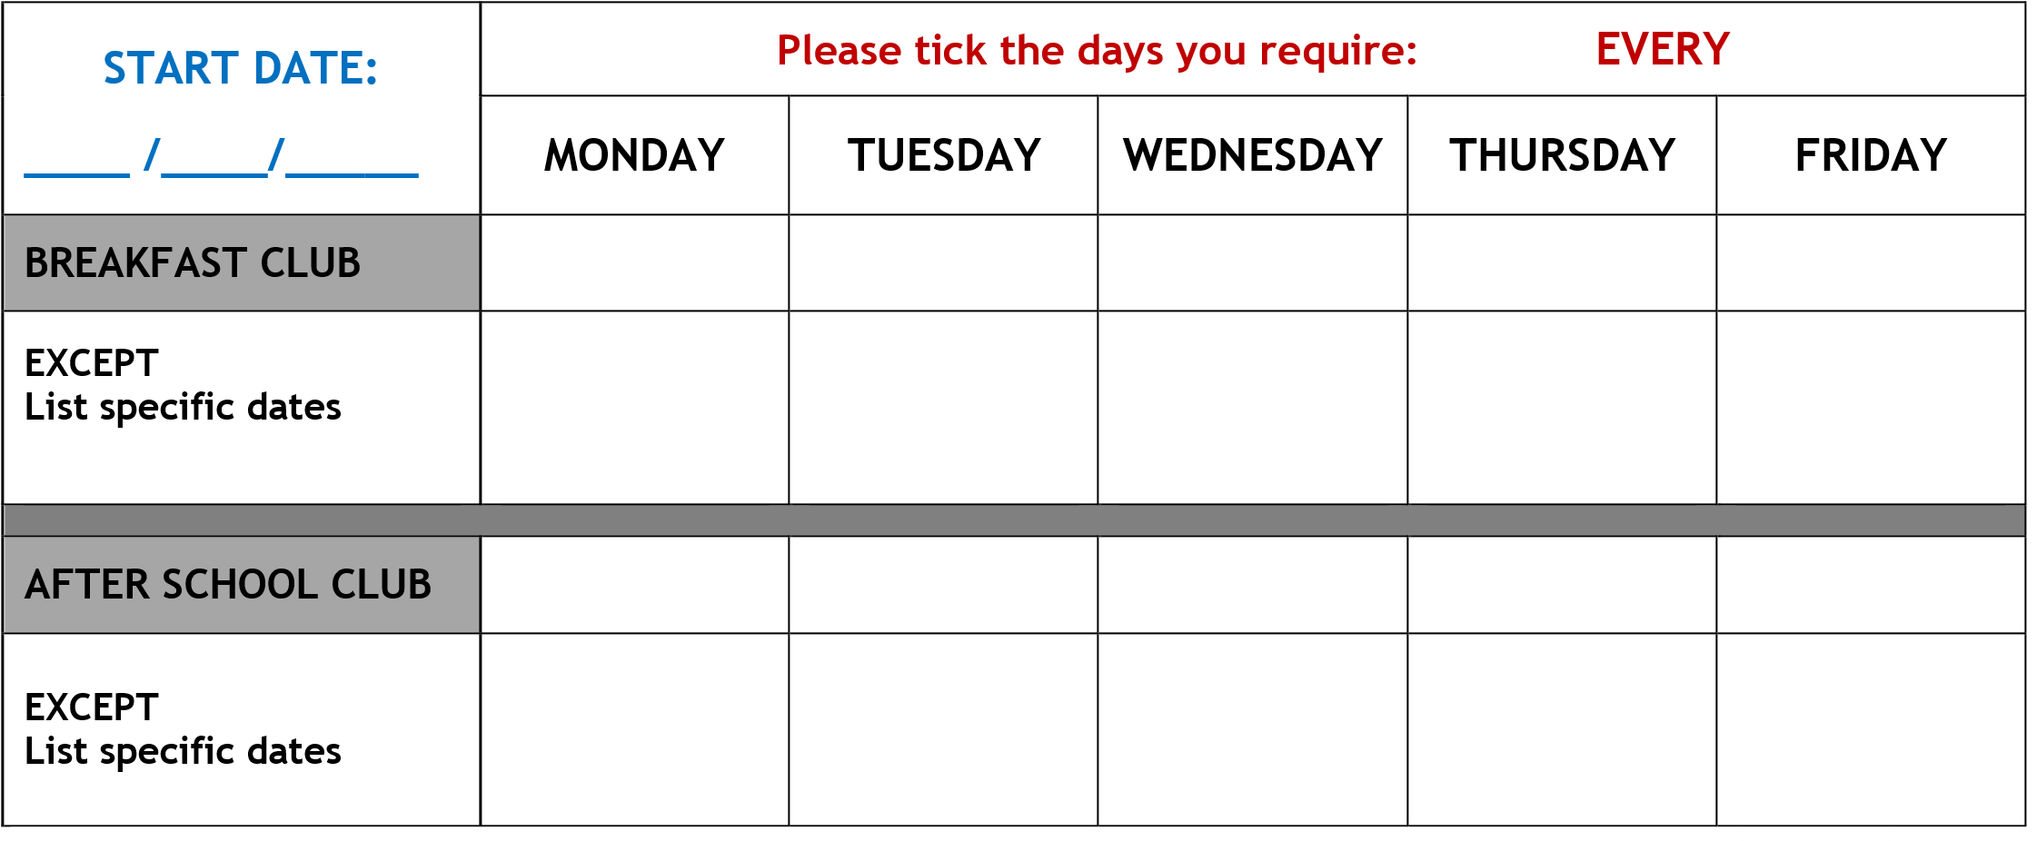

We do not charge for non-attendance on INSET days and will credit you for these days if they are not known at the time of invoicing.
PLEASE NOTE: ALL PLACES BOOKED WILL BE CHARGED FOR WHETHER YOUR CHILD ATTENDS OR NOT unless you give us 10 days’ notice of non-attendance. I agree to the payment & booking terms.
Signed:________________________________________________ Dated:______________________

Please send your completed form to: Natalie Lang, 15 Pellings Rise, Crowborough, East
Sussex, TN6 2RZ or email to newtonlangcc@gmail.com

Newton Lang Childcare - Booking Form – 2020/2021
Newton Lang Childcare

September 2020 to August 2021
Term | Start date | End date
Summer school holiday | Wednesday 22 July 2020 | Thursday 3 September 2020
School INSET day | Thursday 3 September 2020
School Term 1 | Friday 4 September 2020 | Friday 23 October 2020
Autumn school holiday | Monday 26 October 2020 | Friday 30 October 2020
School Term 2 | Monday 2 November 2020 | Friday 18 December 2020
Christmas school holiday | Monday 21 December 2020 | Friday 1 January 2021
School Term 3 | Monday 4 January 2021 | Friday 12 February 2021
February school holiday | Monday 15 February 2021 | Friday 19 February 2021
School Term 4 | Monday 22 February 2021 | Thursday 1 April 2021
Spring school holiday | Friday 2 April 2021 | Friday 16 April 2021
School Term 5 | Monday 19 April 2021 | Friday 28 May 2021
Early May bank school holiday falls in Term 5 | Monday 3 May 2021
May school holiday | Monday 31 May 2021 | Friday 4 June 2021
School Term 6 | Monday 7 June 2021 | Friday 23 July 2021

https://new.eastsussex.gov.uk/educationandlearning/schools/termdates

Terms: Fees are payable monthly in advance. We will not charge you for an Inset day. If an Inset day is not known at the time of invoicing, we will credit you for the day. We require 10 days’ notice for a change or cancellation of a day booked above without which you will be charged. We will adjust and send you an amended invoice for any changes but this will usually only happen once a month or on request. Please notify us of changes in writing, by text message or email. Non receipt of invoice is no excuse for non-payment of fees. Late payment of fees will incur an administration fee of £5.00 per week until payment is received and we reserve the right not to admit your child/children until all fees and surcharges have been received in full. A late collection fee of £5.00 per 15 minutes or part thereof is payable after 6.30pm. We accept payment by childcare vouchers or direct bank transfer. Payments by cheque and cash deposits incur additional banking charges. Please discuss with us if you have any questions.

Newton Lang Childcare - Booking Form – 2020/2021

